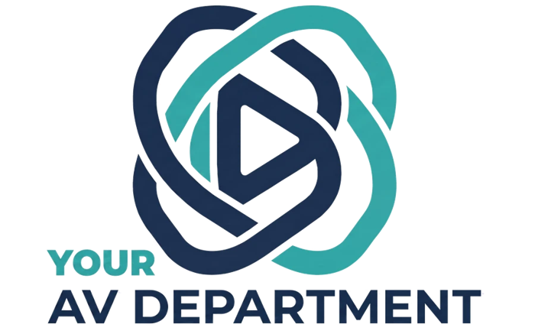

BUSINESS PLAN
Internal Strategy Document

Harward Consulting, LLC dba Your AV Department
Michael Harward, Founder
September 2026
michaelh@youravdept.com | 502.418.3488 | youravdept.com

Executive summary
Your AV Department (YAVD) runs AV production sourcing and project management for national associations and corporate groups, and the client pays nothing for it. YAVD earns 10% of the awarded production spend, net of freight and travel, paid by the winning vendor. The goal is 15 events a year by year two, run by Michael and Trisha with about $500 a month in overhead.
- What planners get: a competitive RFP, a like-for-like bid comparison, negotiated pricing, and one constant contact from first call to show day.
- Why it works: 30 years of vendor relationships across the country, and a model no other sourcing firm is known to offer.
- What it costs to run: no inventory, no crew, no payroll beyond the two owners. Nearly every dollar of fee revenue is margin.
- Base case: at an average $150K production, each event earns about $12,750. Fifteen events is roughly $191K a year.

The problem
Most planners buy AV without a fair way to compare it, so they either accept the in-house quote or pick an outside company they already know. Neither choice tests the price.
- AV is opaque. Bids list gear and labor differently, so two quotes are rarely comparable line for line.
- Labor drives cost, and it is hard to see. Crew size, travel vs. local hires, and schedule set most of the bill (the five levers in The Levers of Labor).
- In-house vendors have leverage. Venue exclusives, patch and rigging fees, and short timelines push planners toward the default option.
- Planners are stretched thin. AV is one line among dozens, and few have the technical depth to challenge a scope.

The offer
YAVD acts as the client's AV department: it scopes the show, runs the bid, and stays on through show day, at no cost to the client.
- Discovery: learn the event, the goals, the venue contract and the budget.
- Scope: right-size the equipment and labor so vendors bid the same show.
- RFP: invite qualified vendors, including the in-house provider when it makes sense.
- Compare and negotiate: level the bids, push on price and terms, recommend a winner.
- Award: the client signs with the vendor directly and talks to them directly.
- Manage to show day: Michael and Trisha stay the constant contact through planning, onsite and wrap, without acting as a gatekeeper.
The client keeps the vendor relationship. YAVD brings the process, the leverage and the experience.

Revenue model
The winning vendor pays YAVD 10% of the production invoice after freight and travel are taken out. The client is never billed.
YAVD fee = 10% × (production invoice − freight − travel)
Example | Amount
Production invoice | $150,000
Less freight and travel (assumed 15%) | -$22,500
Commissionable spend | $127,500
YAVD fee (10%) | $12,750

- Why vendors pay it: YAVD hands them a qualified, scoped opportunity with no sales cost, which is cheaper than finding the client themselves.
- Why it excludes freight and travel: those are pass-through costs, so the fee tracks the real production work and doesn't reward a vendor for being far away.
- How it's secured: a letter of agreement to join the RFP sets the fee up front; the full contract and T&C at award makes it binding (see Operations).
- Disclosure: the model is published on the website, so clients know how YAVD is paid before the first call.
Onsite travel: YAVD charges no fee for time on site. When YAVD attends, the client covers one hotel room and one airfare (booked by Michael to use his rewards). Onsite attendance is optional.

Market and competition
YAVD's real competitor is the planner's default choice, not another sourcing firm. No other AV sourcing company is known to use this model.

Target clients
- National associations with an annual meeting or conference, like IADR, AOPA, AACSB and NAESP.
- Corporate groups running sales meetings, launches and user conferences, like Tech Data, Brown-Forman and Humana.
- Best fit: events with a production spend large enough to justify a real RFP, and a planner without an in-house AV lead.

Alternatives planners choose today
Alternative | Why planners choose it | Where YAVD wins
In-house venue AV | Convenient, bundled with the venue, no extra vendor to manage | Competitive pressure on price, scope review, a second opinion on fees
Outside production company (direct) | Known relationship, higher production quality | Proof the price is fair, access to more vendors, one advocate across all of them
Doing nothing different | No time to run a bid | YAVD runs the bid for them at no cost

Go-to-market
Fifteen events a year needs a steady pipeline, so most early effort goes to getting in front of planners before their AV is contracted.
- Network first: 30 years of client and vendor contacts. Former clients are the fastest first wins, and vendors can refer planners who want a competitive bid.
- Content and lead magnets: the library guides, starting with The Levers of Labor, capture planner emails; Why Is AV So Expensive? and the playlists build trust.
- LinkedIn: regular posts on right-sizing equipment and labor, aimed at meeting professionals.
- Industry events: ASAE, PCMA and MPI gatherings where association and corporate planners meet.
- Targeted prospecting: build a list of associations by annual meeting date and size, and reach them 9 to 18 months before the show, when AV is still open.
Pipeline math (assumption): if about half of qualified opportunities convert, 15 events needs roughly 30 qualified conversations a year, or 2 to 3 a month.

Operations
Vendors are brought in case by case, with two documents protecting the fee: a letter of agreement to bid, and a full contract with T&C to be awarded.
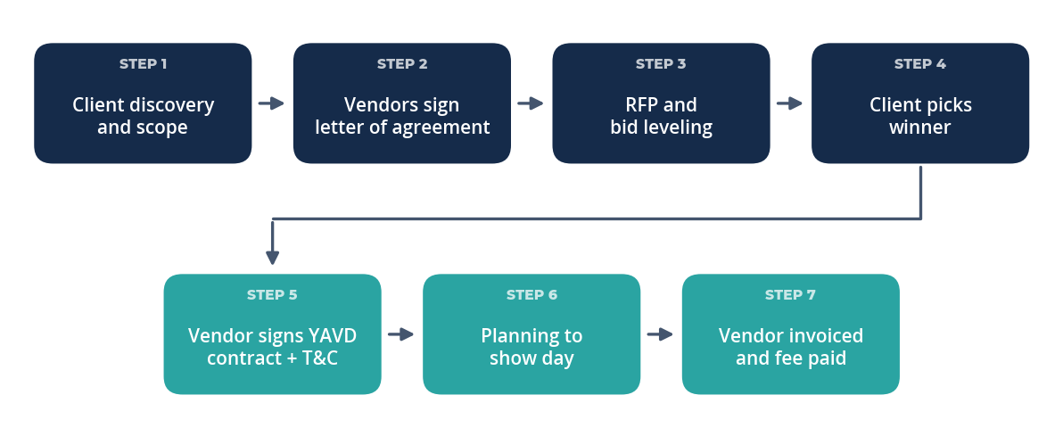
No vendor sees the RFP until it signs the letter, and no vendor is awarded until it signs the contract.

Letter of agreement (to bid)
- Fee terms: 10% of the production invoice, net of freight and travel.
- Confidentiality of the client's RFP and budget.
- Agreement not to go around YAVD to the client for this event.

Contract and T&C (to be awarded)
- Fee payment timing, for example within 30 days of the vendor being paid by the client.
- YAVD's right to see the final invoice so the fee can be verified.
- Non-circumvention: lasts 24 months after the end of YAVD's most recent active project with that client.
- Change-order handling, so scope added after award is included in the fee.
- Insurance: the vendor provides a certificate of insurance for each event naming YAVD as additional insured.

Roles
Person | Focus
Michael Harward, Founder | Sales, vendor relationships, scoping, negotiation, onsite leadership
Trisha Harward, Director of Client Solutions | Client communication, RFP administration, schedules, documentation

Financial projections
In the base case, YAVD earns about $191K in fees in year two at 15 events, against about $6K a year in overhead. Average production spend per event is the biggest unknown, so the plan also shows a lower and a higher scenario around the $150K base.
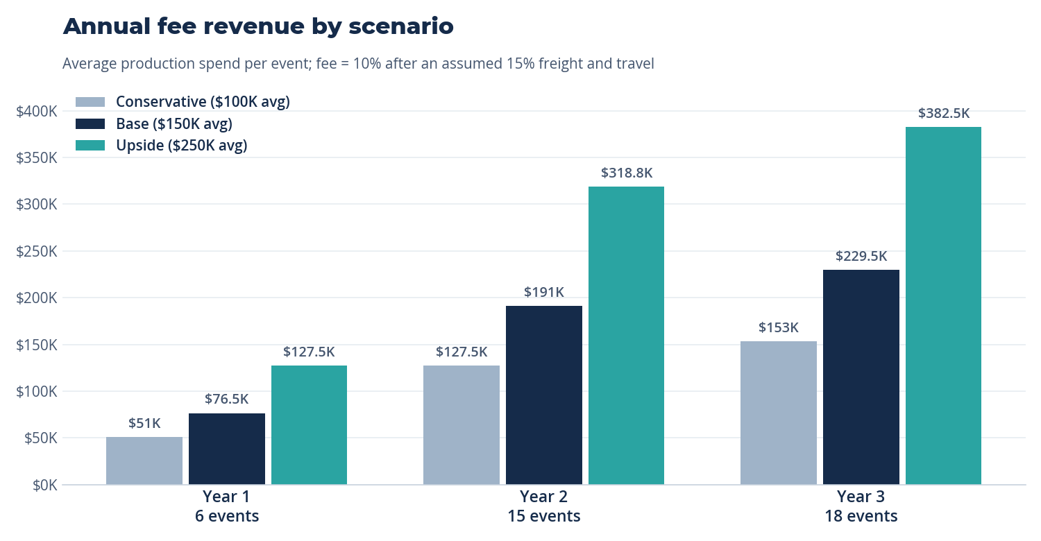
Planning assumptions, not bookings.
Year | Conservative ($100K avg) | Base ($150K avg) | Upside ($250K avg)
Year 1 (6 events) | $51,000 | $76,500 | $127,500
Year 2 (15 events) | $127,500 | $191,250 | $318,750
Year 3 (18 events) | $153,000 | $229,500 | $382,500

Assumptions
- Event count: 6 in year 1, 15 in year 2, 18 in year 3.
- Average production spend: $150K per event (base case).
- Freight and travel average 15% of the production invoice.
- Overhead is $500 a month ($6K a year) for subscriptions and tools. No inventory, no other labor.
- Onsite travel is paid by the client, so it adds no cost to YAVD.
- Michael and Trisha are paid from what remains, so owner pay is the profit line.
Cash timing: fees arrive after the vendor is paid, often 30 to 60 days after show day. Association meetings are booked 9 to 18 months out, so year-one cash will lag signed work. Plan personal runway for that gap.

Risks and mitigations
The biggest risks are vendors declining the fee and clients suspecting it inflates their price.
Risk | Mitigation
In-house or venue-exclusive vendors refuse to sign the letter of agreement | Make signing the entry ticket to the RFP; when an exclusive won't sign, compete them against outside vendors and reserve the right to recommend against them
Clients assume vendors pad bids to cover the 10% | Publish the model, level bids line by line, and show savings against the first quote
Vendor pays late or disputes the fee base | Contract sets payment timing and gives YAVD the right to see the final invoice
Vendor goes around YAVD on the next year's event | Non-circumvention for 24 months after the most recent active project
Long sales cycle slows year one | Start with former clients and events already in planning; keep 2 to 3 new conversations a month
Two-person capacity during peak season | Stagger show dates when possible; Trisha owns admin so Michael can cover onsite

Milestones and next 90 days
The next 90 days are about signing the first events and locking the paperwork.
☐ Finalize the vendor letter of agreement (have an attorney review)
☐ Finalize the award contract and T&C
☐ Build a standard RFP template and bid-leveling sheet
☐ Contact 50 past clients and planners from the network
☐ List target associations by annual meeting date, 9 to 18 months out
☐ Publish a second library guide and post weekly on LinkedIn
☐ Sign the first 2 events

Milestone | Target
First event awarded | By end of Q1 2027
6 events contracted | End of year 1
Form Your AV Department, LLC and move operations into it | End of year 1
15 events a year | Year 2

Decisions
Question | Decision
Average production spend | $150K per event (base case)
Year-one event count | 6 events
Onsite travel | Optional; client covers 1 hotel room and 1 airfare; no fee for time on site
Non-circumvention | 24 months after the end of the most recent active project
Insurance | Vendor provides a certificate of insurance per event naming YAVD as additional insured
Business entity | Operates now as Harward Consulting, LLC dba Your AV Department; split off Your AV Department, LLC at the end of year 1

When the new LLC forms, vendor letters, contracts and certificates of insurance will need to name Your AV Department, LLC.

